REVIEW
- Look and write.

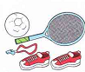
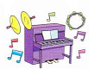

_____________ _____________ _____________

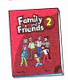
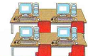

_____________ _____________ _____________

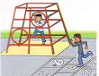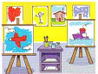

_____________ _____________

- Order the letters.
- o o b l l n a ______________
- k a e c ______________
- d c a r ______________
- y d c n a ______________
- s n t u ______________
- i t e ______________
- e i n h g o r b ______________

- Order the words.
- Monday / we / What / have / do / on
____________________________________?
- math / have / we
________________.
- do / have / When / we / English
____________________________________?
- are / These / P.E. / bags / our
____________________________________.
- clothes / you / wear / can / their
____________________________________.
- These / T-shirt / are / their
____________________________________.
- bags / Those / our / are
____________________________________.
- art / have / When / you / do
____________________________________?
- you / do / When / music / have
____________________________________?
- Thursday / have / I / math / on
____________________________________.
- have / P.E. / Friday / on / I
____________________________________.
- Monday / you / have / Do / English / on
____________________________________.

- do / like / What / you
____________________________________?
- does / What / like / he
____________________________________?
- not / do / candy / like / I
____________________________________.
- balloons / does / he / not / like
____________________________________.
- Look and answer the questions.

music
P.E.
art
English
math

- What do you have on Monday? ____________________________.
- What do you have on Thursday? ____________________________.
- When do you have music? ____________________________.
- When do you have English? ____________________________.
- Do you have P.E. on Tuesday? ____________________________.
- Do you have art on Wednesday? ____________________________.

