REVIEW 3

- Write

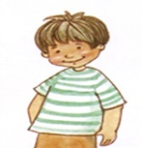  0. | 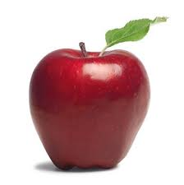1.
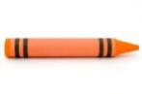  2. | 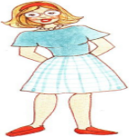  3.
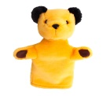  4. | 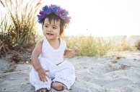  5.
II .Circle the answers.
1.How many girls?
two
three
2 .How many apples?
three
five
3. How many cookies? 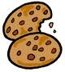
one
four
4. How many teachers? three
five
III.Color.
1. Color the crayon green 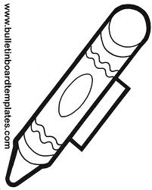

2. Color the motorcycle pink 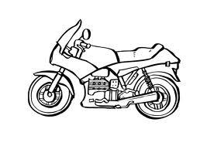

3. Color the truck yellow 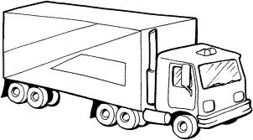

4. Color the bus blue 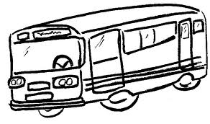

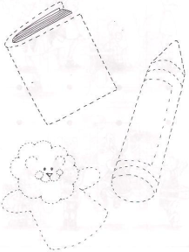
IV.Match
1 2 3 4 5

Two One three Five Four

