REVIEW - GRADE 3

I. Write the words. :EXAMPLE: O = ONE

B.......................
D. .......................
C. .......................
F. .......................
S. .......................
I. .......................
P. .......................
T .......................
N .......................
M. ......................

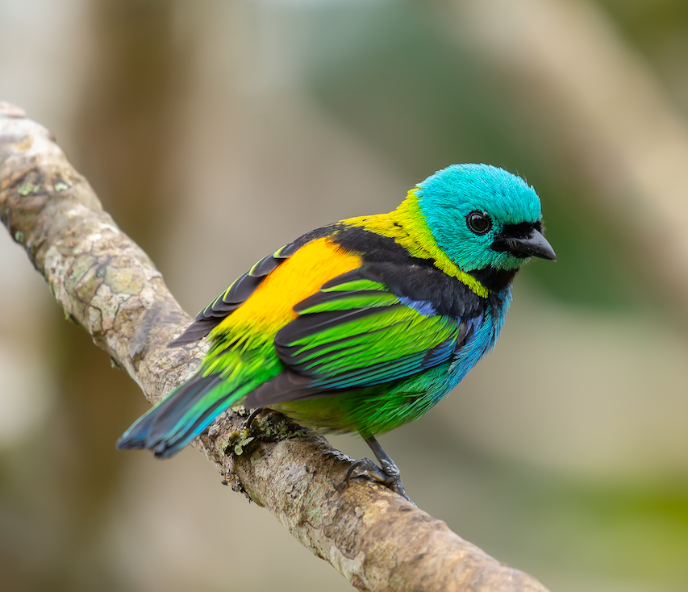
II. Fill in the blanks.

- What's .................. name?
- .................... name's Tim.
- How ................. are you? .....pple ....ird
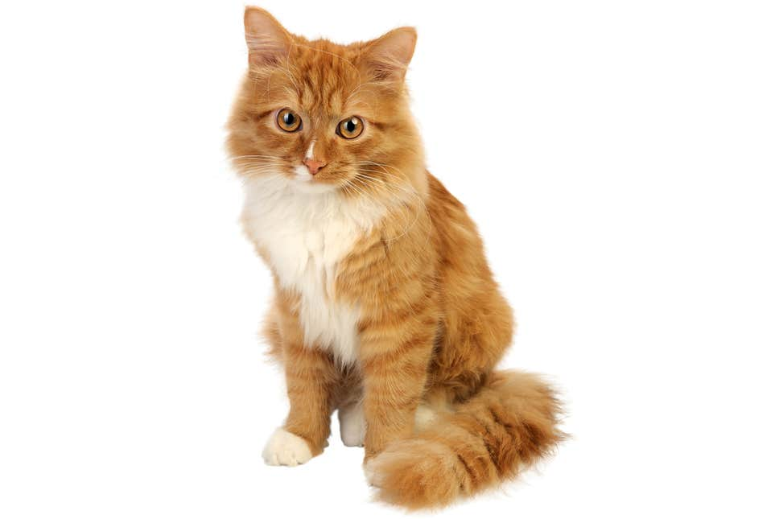

- .................. nine.
- .................... this?
- ...................... a pencil case. .....at ... og

III. Look at the pictures and write the words.
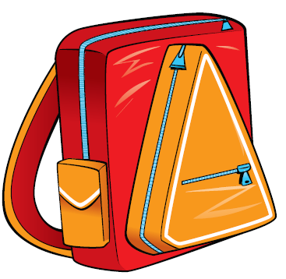
Hi, my name's Rosy. This is my ......................... .............................
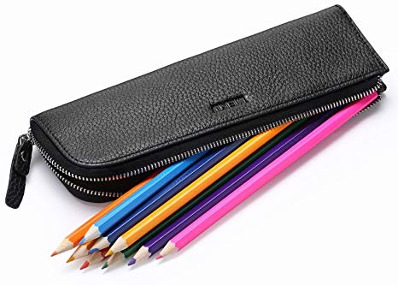
This is my ............................ It's blue and yellow. ............................

This is my green ........................ ............................
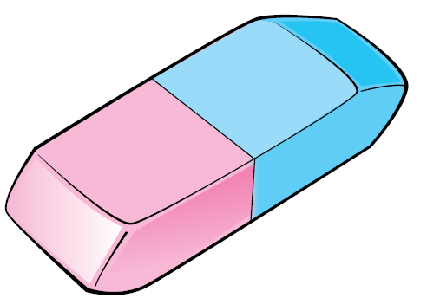
Look at this. It's ............................. .............................

IV.. Find and circle seven the words about family (Tìm và khoanh tròn8 từ chỉ gia đình) (1point)

G | R | A | N | D | P | A | R | G | U | O | N
D | S | W | P | A | I | M | O | M | A | X | S
A | C | S | K | L | N | E | A | D | G | B | I
D | O | V | T | A | O | I | R | I | O | C | S
I | U | T | C | S | H | U | C | O | L | D | T
O | S | H | I | D | T | L | E | K | P | A | E
L | I | C | P | H | B | R | O | T | H | E | R
K | N | W | E | D | T | H | E | R | H | J | M
Y | G | N | U | N | E | H | T | S | M | E | B

